FreeBAC，当banker为6且赢了时，赔率为0.5

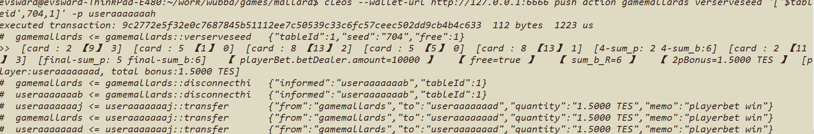

BAC tie下注 2.0000 TES 且赢了时，赔率为8，delaerBalance的剩余金额为4000+7-18-0.045-0.045-0.018=3988.8920 TES

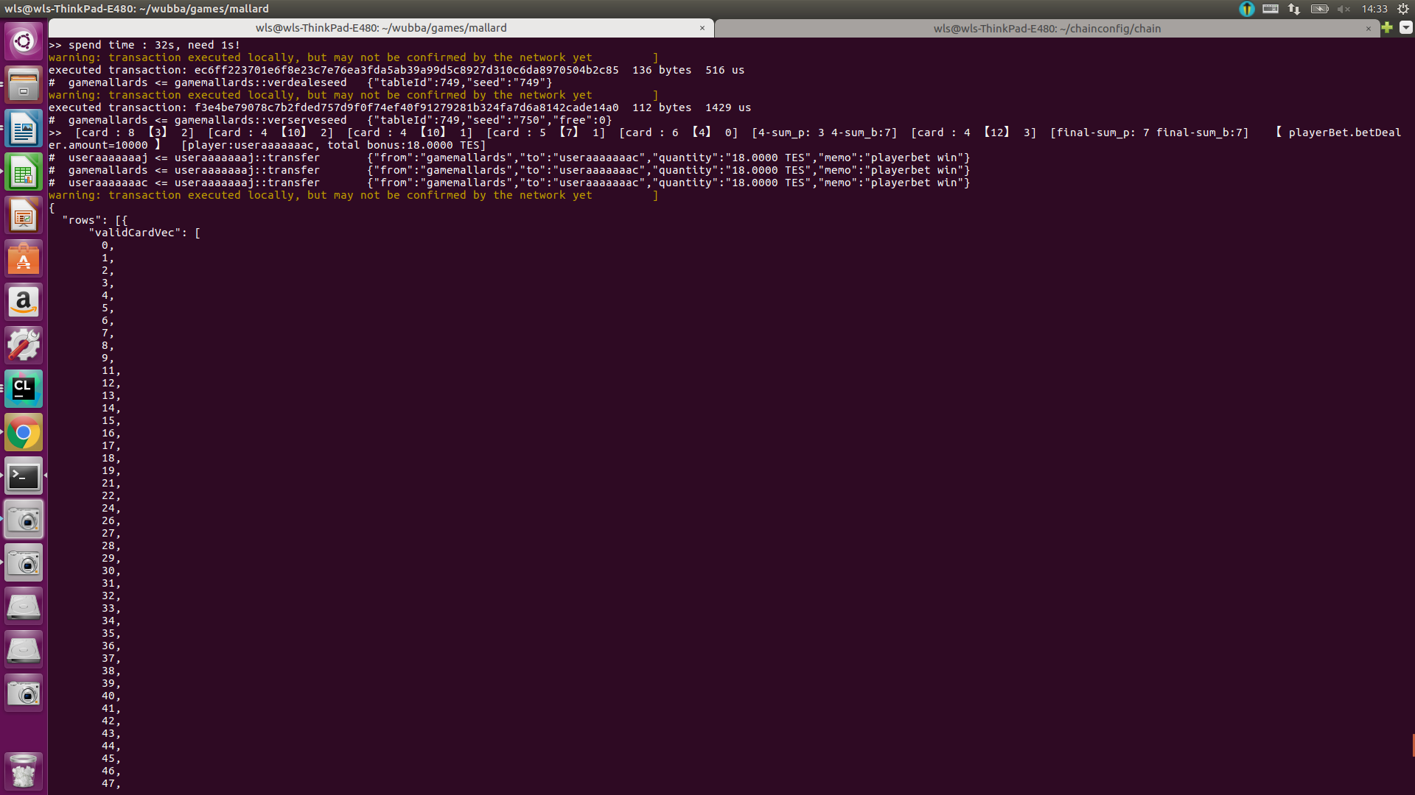

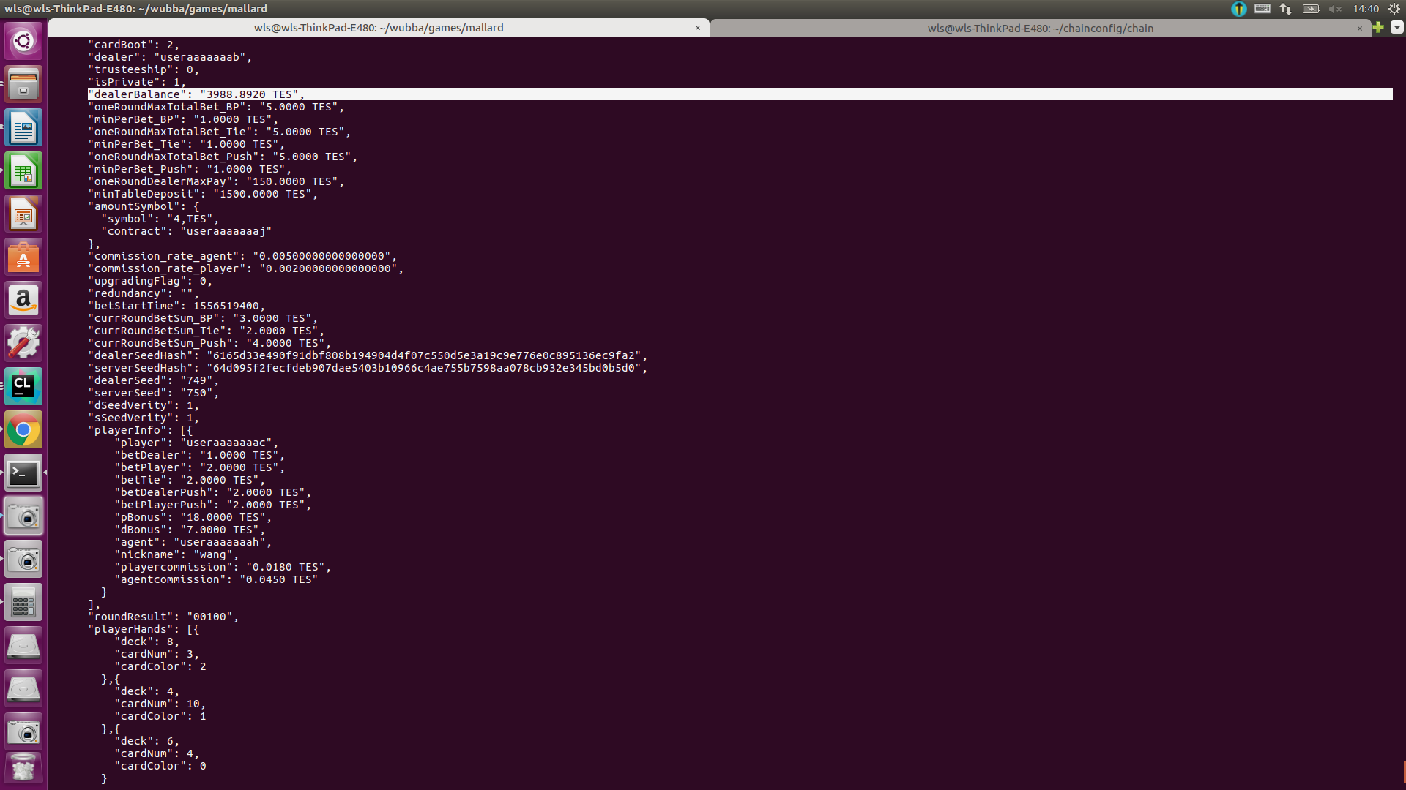

bac dealer下注1.5000 TES并且只有delaer胜时，赔率为0.95 ，返还给player 2.9250 TES，总的下注额度为6.6 TES 所以返个player的佣金为6.6×0.002=0.0132 返给agent和平台的佣金为6.6×0.005 = 0.0330 TES 最后剩余的dealerBalance为4000+5.1-2.9250-0.033-0.033-0.0132=4002.0958 TES

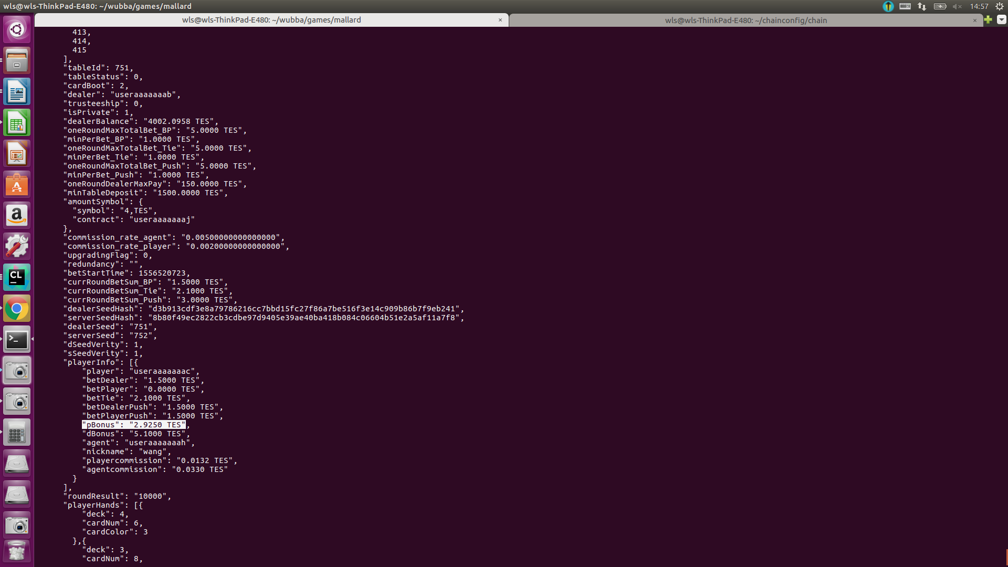

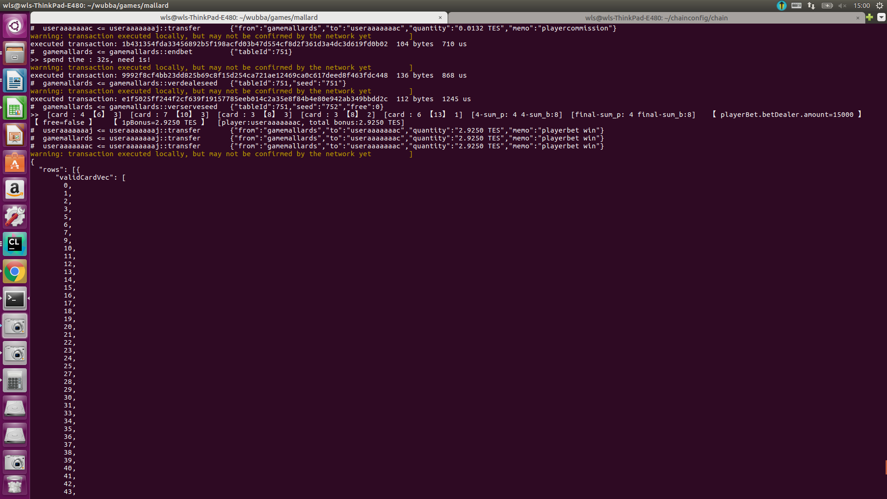

bac player下注并且只有player赢了 赔率1，返给player的钱为1.02×2=2.04 TES 剩余下注的钱（1.1+1.5+1.5=4.1）直接划入dbonus。player的佣金为5.12×0.002=0.0102，agent和平台的佣金为5.12×0.005=0.0256。dealerBalance剩余钱为4000+4.1-2.04-0.0102-0.0256-0.0256=4001.9986 TES

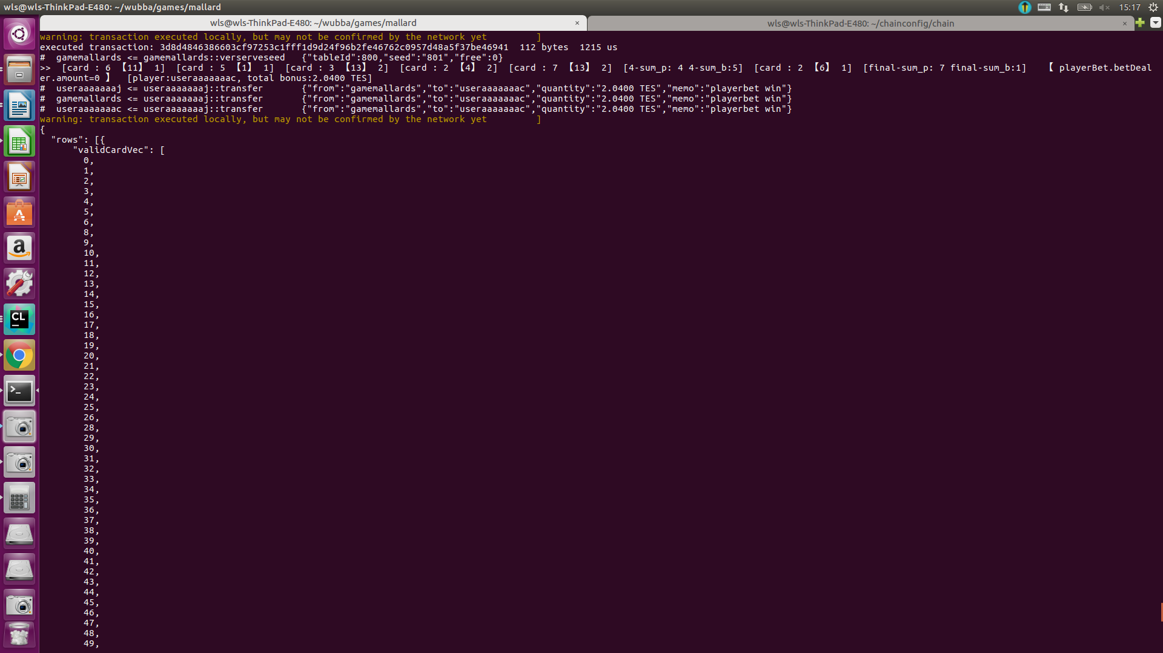

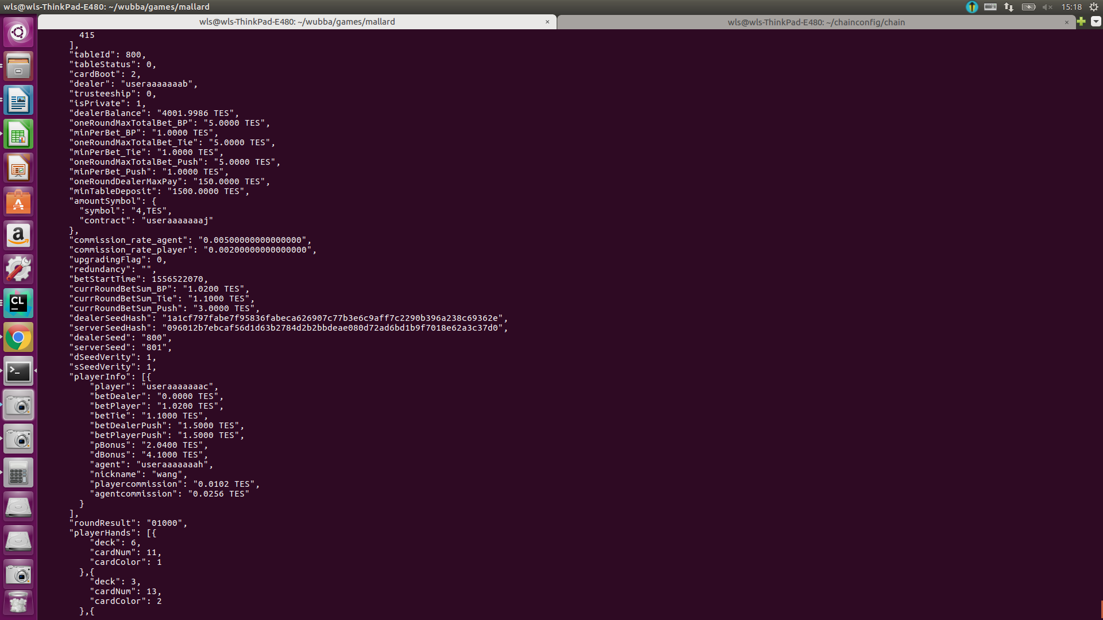

bac player下注 player赢了，赔率为1，并且 dealerPush赢了，赔率为11 一共返给player的钱为1.02×2+1.5×12=20.04,剩余下注的钱返给dBonus为1.1+1.5=2.6。dealerBalance剩余的钱为4000+2.6-20.04-0.0102-0.0256-0.0256=3982.4986

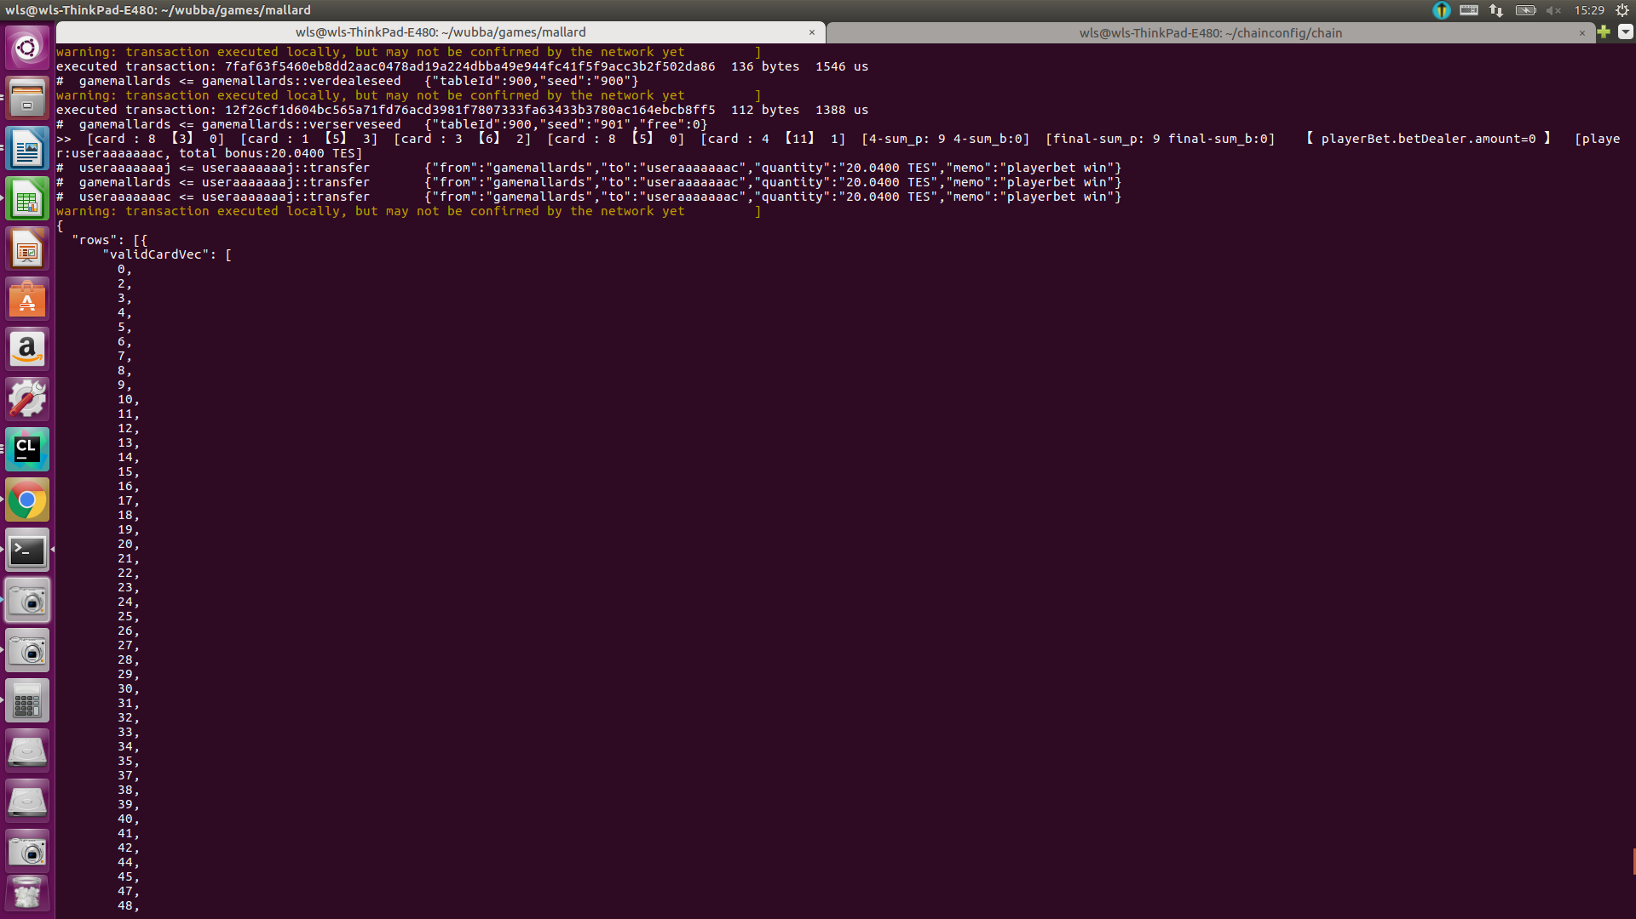

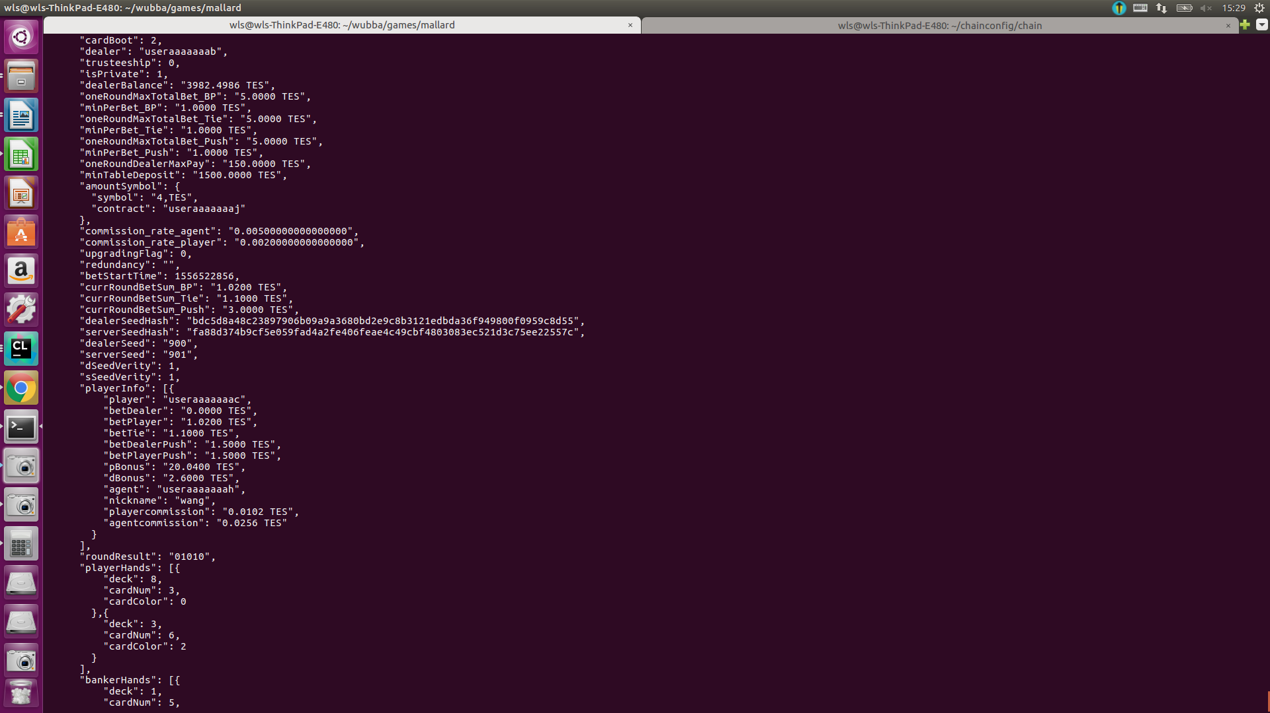

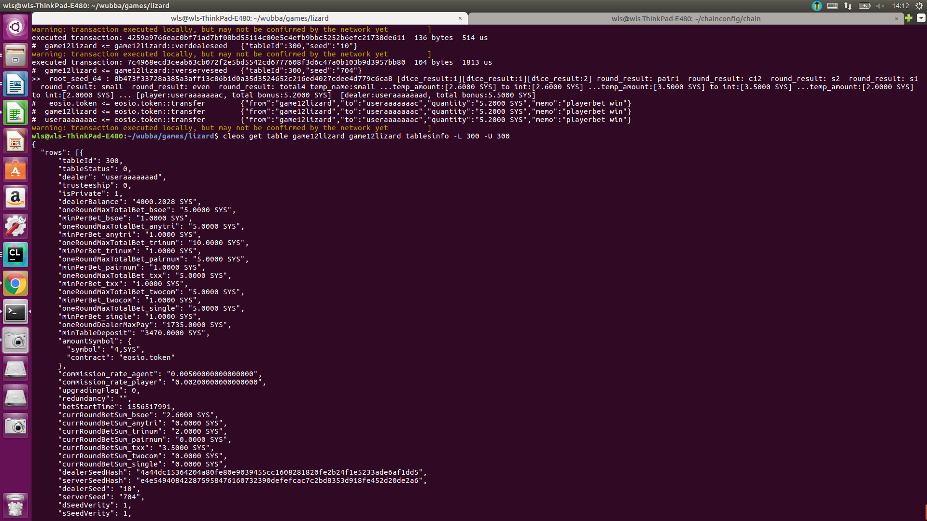lizard 下注small且赢了时 赔率为1，返给player钱为2.6×2=5.2000 SYS ，dealerBalance的剩余额度为4000+5.5-5.2-0.0162-0.0405-0.0405=4000.2028 SYS

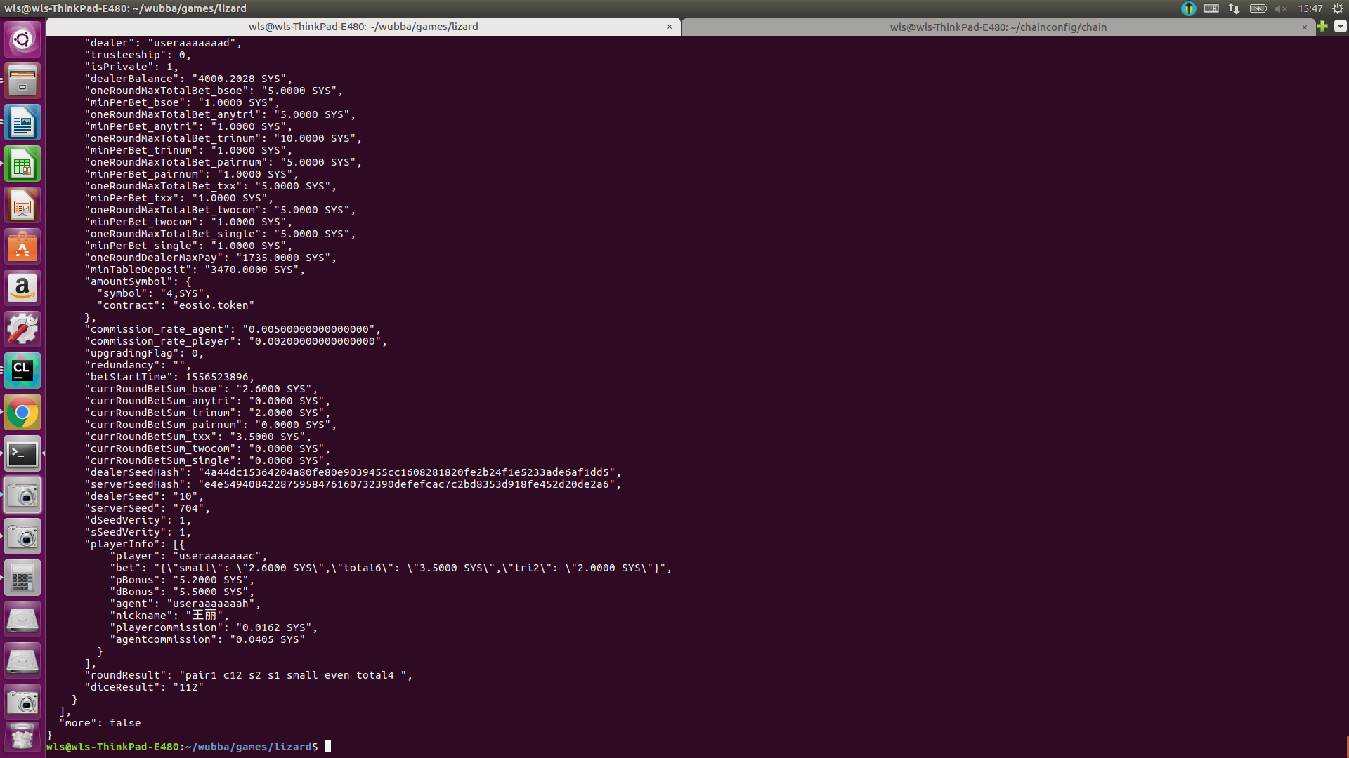

lizard 下注信息 一个都没赢，delaerBalance的剩余为 4000+11.2-0.0224-0.056-0.056=4011.0656 SYS

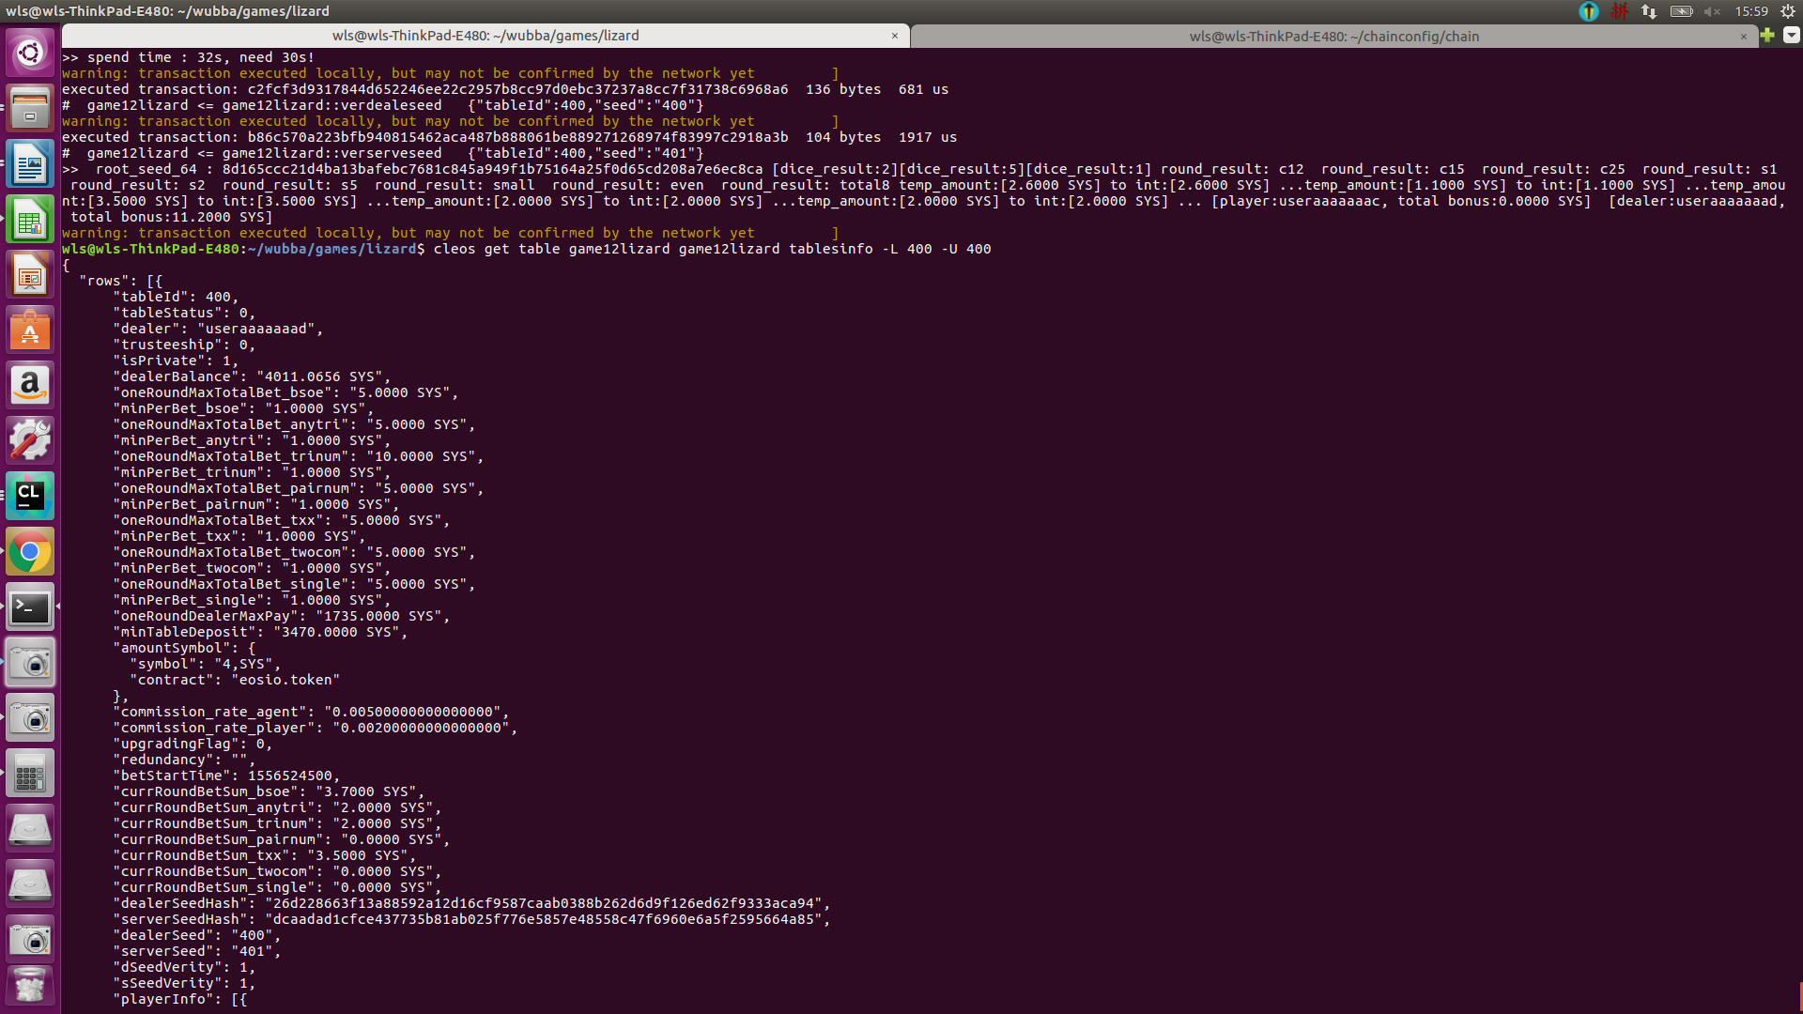

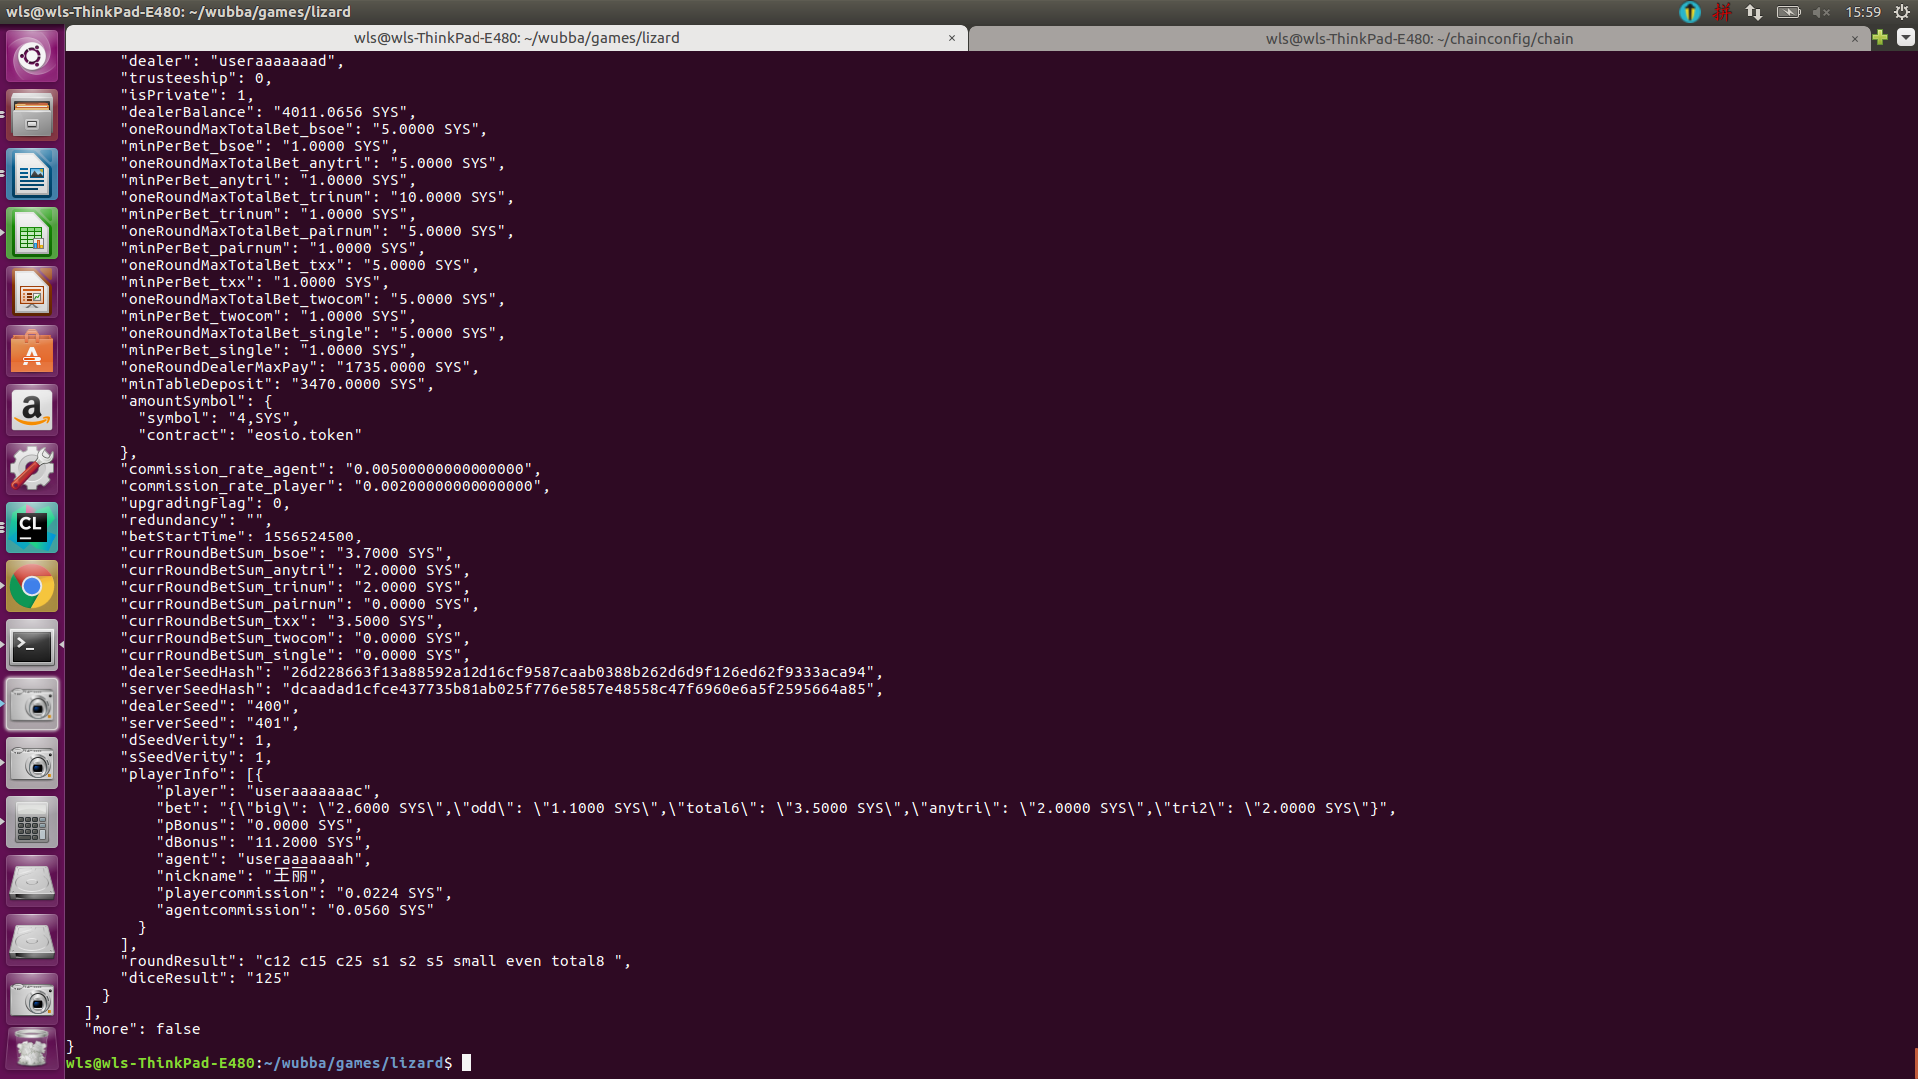

lizard

下注信息{\"big\": \"2.6000 SYS\",\"even\": \"1.1000 SYS\",\"total8\": \"3.5000 SYS\",\"anytri\": \"2.0000 SYS\",\"s3\": \"2.0000 SYS\"}"

结果："roundResult": "c34 c36 c46 s3 s4 s6 big odd total13 ",

"diceResult": "346"

分析：big赢 赔率为1 s3赢赔率为1 总返回给player钱为2.6×2 + 2×2= 9.2000 SYS

delaerBalance剩余额度为 4000+6.6-9.2-0.0224-0.0560-0.0560=3997.2656 SYS

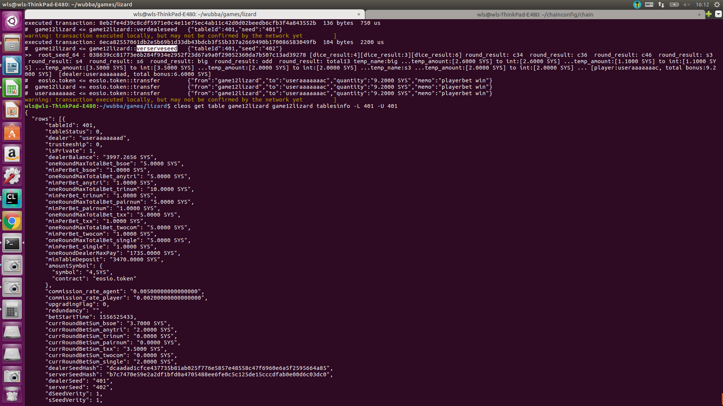

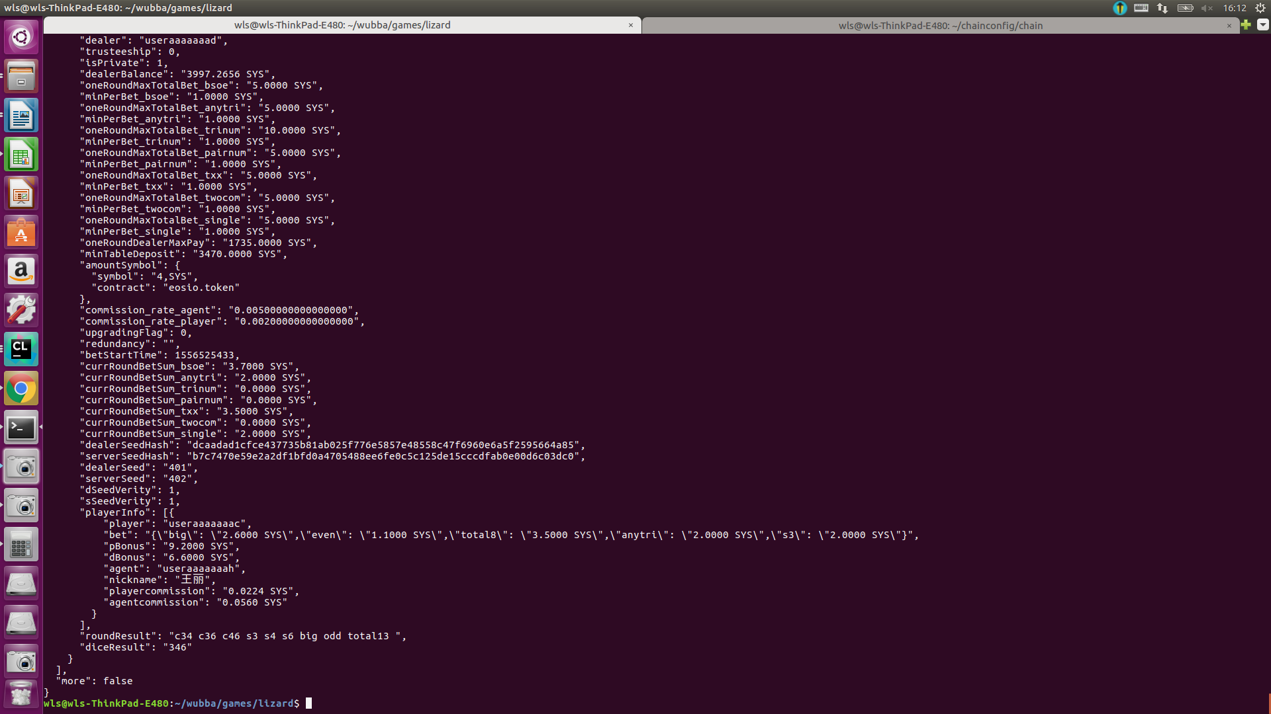

lizard

下注信息{\"big\": \"1.2000 SYS\",\"odd\": \"1.1000 SYS\",\"total13\": \"3.5000 SYS\",\"c34\": \"2.0000 SYS\"}

结果："roundResult": "c34 c36 c46 s3 s4 s6 big odd total13 ",

"diceResult": "346"

分析：big赢 赔率为1 odd赢赔率为1 total赢的赔率为8 c34赔率为5 总返回给player钱为1.2×2 +1.1×2 + 3.5×9 + 2×6= 48.1000 SYS

delaerBalance剩余额度为 4000-48.1-0.0156-0.0390-0.0390=3951.8064 SYS

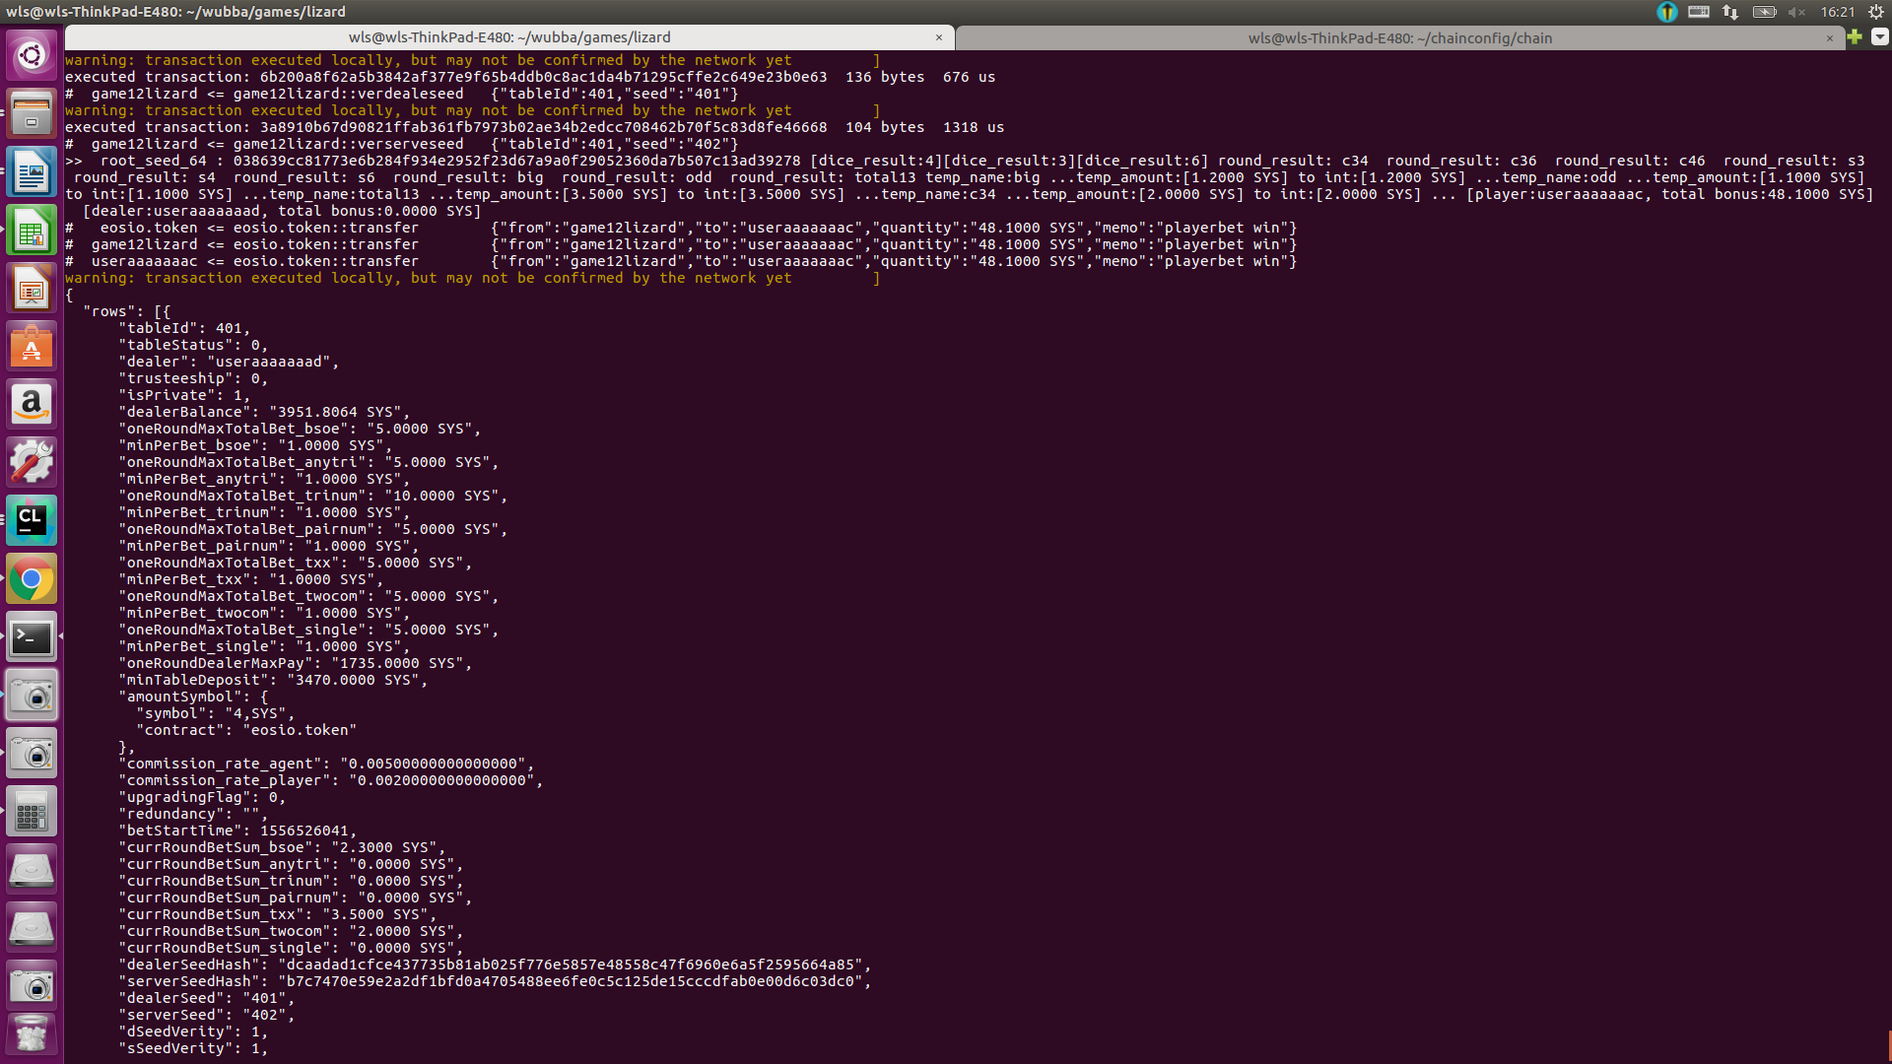

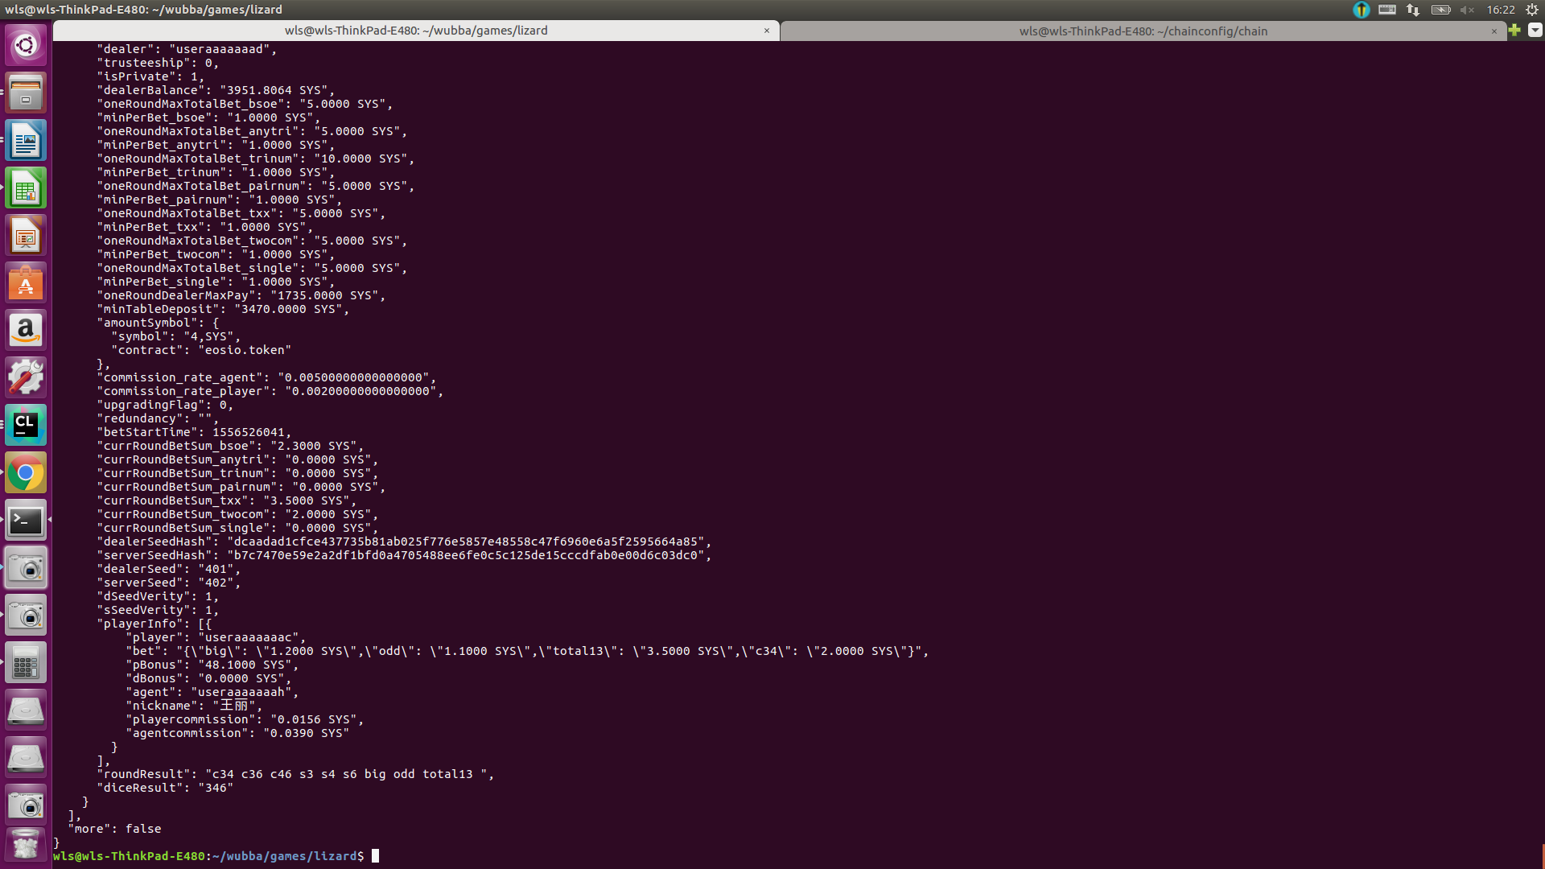

lizard

下注信息{\"big\": \"1.2000 SYS\",\"odd\": \"1.1000 SYS\",\"total13\": \"3.5000 SYS\",\"anytri\": \"2.0000 SYS\",\"tri1\": \"2.0000 SYS\",\"pair1\": \"2.3000 SYS\"}"

结果："roundResult": "pair1 c14 s4 s1 small even total6 ",

"diceResult": "114"

分析：pair的赔率为8 总返回给player钱为2.3×9= 20.7000 SYS

delaerBalance剩余额度为 4000-20.7+9.8-0.0242-0.0605-0.0605=3988.9548 SYS

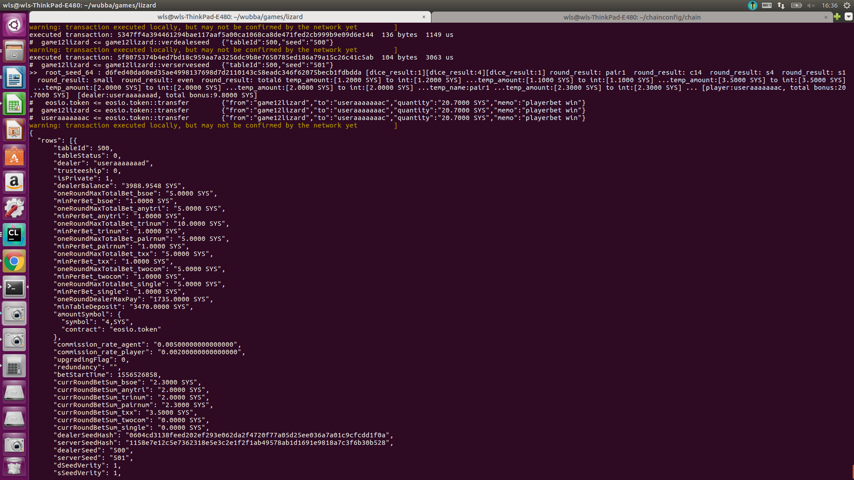

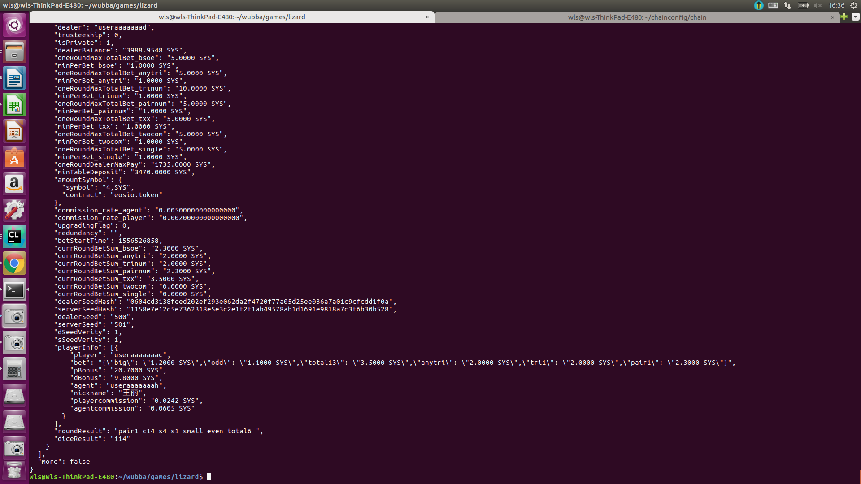

lizard

下注信息"{\"big\": \"1.2000 SYS\",\"odd\": \"1.1000 SYS\",\"total13\": \"3.5000 SYS\",\"anytri\": \"2.0000 SYS\",\"tri1\": \"2.0000 SYS\",\"pair6\": \"2.3000 SYS\"}"

结果："roundResult": "pair6 c36 s3 s6 big odd total15 ",

"diceResult": "366"

分析：big 赔率为1,odd赔率为1,pair的赔率为8 总返回给player钱为1.2\*2+1.1\*2+2.3×9= 25.3000 SYS

delaerBalance剩余额度为 4000-25.3+7.5-0.0242-0.0605-0.0605=3982.0548 SYS

